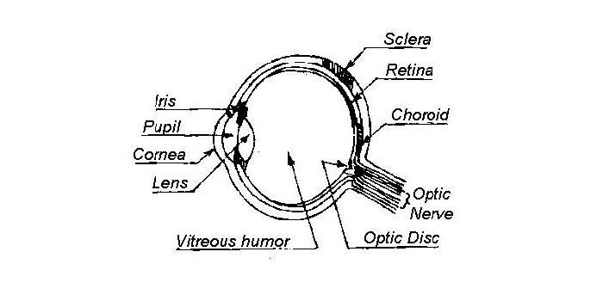
AN EXPLANATION OF EYE DISEASE
by Gayle Kaye, edited by Nancy M Bromberg, VMD, MS, DACVO
Like people, Dogs are subject to a large number of inherited eye diseases. There are two which can seriously affect a Collies eyes and should be of concern to all breeders.
COLLIE EYE ANOMALY
This is the most common of the Collie eye diseases, but it should be noted that Collies share this disease with several other breeds. Researchers first noted this problem over fifty years ago. It was later found to exist in most Collies and in most Collie families. This so-called syndrome (meaning a group of conditions which appear in conjunction with each other) is present prior to birth. Collie Eye Anomaly (CEA) can be easily checked when the puppies are 6-8 weeks old, by a Board Certified Ophthalmologist. The eyes must be dilated prior to the examination, so the interior of the eye can be examined with an ophthalmoscope.
If the puppy’s eyes are not normal, the actual abnormality is noted. A grading system is no longer used.
Normal: A “Normal” eye rating is, of course, ideal. The only way to determine if a Collie is genetically normal is a DNA test. There are variations even in “Normal” eyes. These correspond somewhat to a dog’s coat color. It is often difficult to judge choroidal hypoplasia in a Blue Merle’s eyes as the retinal pigment is diluted along with his coat color.
Choroidal Hypoplasia, Chorioretinal Change: These refer to abnormalities in the development or pigmentation of the choroid. The choroid is a vascular bed beneath the retina. This is the most common abnormality found in Collie eyes. It is the least harmful and least severe form of CEA. Most dogs with this eye grade function normally with no obvious vision deficits. Puppies with minimal choroidal hypoplasia may look normal at subsequent examinations because the area fills in with pigment. These puppies used to be referred to as “go normal”, but since they remain affected genetically, the term used now is that the area may be “masked” at a later date.

Retinal folds: retinal folds occur when the developing retina folds on itself. It is commonly seen associated with CEA in puppies. These folds commonly resolve with age.
Staphyloma, Coloboma, Ectasia: While not completely synonymous, these terms all refer to a cupping or bulging in the eyeball usually in the area of the optic disc. These conditions may or may not be of serious nature. It depends on the size and/or where the “bulge/cupping” is located. Large colobomas or severe ectasia of the sclera can lead to retinal detachment.
Vascular Disease, Tortuous Blood Vessels: Defects in the vessels of the eye which are responsible for its blood supply or “nourishment.” These may be malformed, undersized, or even lacking.
Retinal Detachment: Loosening or separation of the inmost, or retina, layer from the wall of the eye. This may involve a tiny area or the entire retina. It can be either one or both eyes. The complete detachment of the retina results in blindness.
OptiGen now offers genetic tests for Collie Eye Anomaly/Choroidal Hypoplasia and Progressive Retinal Atrophy (rcd2). These genetic tests can distinguish all three genetic states – normal, carrier and affected. This test is a simple cheek swab or blood sample. The test should not take the place of eye exams….nor does it provide information on a dog’s status of any other eye disorder. Please visit the OPTIGEN website for details http://www.optigen.com
Can the Collie’s eyes become worse? Might he later go blind? A dog born with a severe Staphyloma or with Vascular Disease may later suffer loss of vision if a detachment or severe hemorrhage occurs. Most dogs that are mildly affected will generally have perfectly adequate vision throughout their life. (Even a dog with one blind eye will adapt perfectly well in his surroundings.)
What have breeders done to improve Collie eyes? When the eye problem was identified more than 50 years ago, it was estimated that 90% of the Collie population was affected with some form of eye disease. Because CEA has involved such a large percentage of the breed, eradication is difficult. Over the years, with selective breeding and ophthalmic examination of breeding stock, the number of seriously affected Collies has been greatly reduced. ALL reputable breeders should have not only their breeding stock, but all puppies that are offered for sale examined by a board-certified ophthalmologist.
The Collie Club of America’s Code of Ethics requires …
“3. All dogs shall be transferred, sold or placed in good condition, free of communicable diseases with health guaranteed for a reasonable length of time. This should include a written health record, including an inoculation schedule and an eye examination done either by a licensed veterinarian trained in veterinary ophthalmology or a certified ophthalmologist. . It is also suggested that the dogs have some type of permanent identification, such as a microchip or tattoo.”
How is CEA inherited? Most of the specialists agree that Choroidal Hypoplasia is carried as a simple recessive trait. Even among the dogs that are normal on ophthalmoscopic examination, most are carriers of the gene. They carry a recessive gene for the condition and will pass the gene to half their offspring. For a dog to have retinal lesions, both parents must carry a gene for the condition. However, the severity of the condition may be affected by other genetic factors that still need to be identified. The ideal, of course, is to eliminate all but the clear, non-carriers, from breeding. Only dogs with choroidal hypoplasia should be used for breeding. ALL dogs with colobomas, staphylomas, ectasia or detachments should be eliminated from the breeding program The Collie Health Foundation encourages its members to have all their puppies checked as young as possible by a Diplomate of the American College of Veterinary Ophthalmologists. Where there is none in the area, the alternative is to sell a dog contingent on a later check. No dog should be used for breeding until examined and found to be above the examiner’s standard.
PROGRESSIVE RETINAL ATROPHY
Another breed-related eye problem identified less frequently than CEA is Progressive Retinal Atrophy (PRA). PRA is unrelated to CEA. As the name indicates, PRA is a degeneration of the cells of the retina and can result in complete blindness. “PRA”, or rod-cone dysplasia type 2 (rcd2), is a form of retinal degeneration that has been in collies for decades. In this disease, an abnormal development (dysplasia) and then rapid degeneration of the rods and cones (the light sensitive cells in the retina) leads to an early onset of night blindness that may be apparent as early as 6 weeks of age. In most cases, the rcd2-Affected dog is completely blind by the time it is 1 year old.
PRA has proven to be a simple recessive in the majority of the breeds studied. Again, this means that both parents must be carriers. If one parent has PRA, half the puppies may develop PRA if the other parent is a carrier, but all will be carriers for the disease. Early signs of the problem may be noticed by the owner as “night blindness.” The dog has trouble seeing in dim light and will bump things. The dog may see motion, but have difficulty with stationary objects

TWO OTHER CONDITIONS NOT PART OF CEA, WHICH CAN OCCUR, SHOULD BE NOTED:
Corneal Dystrophy: Opaque spots appear on the surface of the cornea. This is usually cholesterol being deposited just under the epithelial surface of the cornea. It’s usually unrelated to the level of cholesterol in either the food or bloodstream, but an inability of the cornea to metabolize the cholesterol. However, it can occur when a bitch is fed higher cholesterol containing food during gestation. The presence of the dystrophy rarely causes discomfort or vision deficits.
Fibrous Histiocytomas/Nodular Fasciitis: Raised, fleshy masses that arise from the temporal (upper and outer) aspect of the conjunctiva and frequently extend into the cornea. These masses are composed predominantly of inflammatory cells and fibrin. Some resolve with topical and/or oral medications, but some require surgery for resolution.

